1. **Writer a C program to check weather a number is palindrome or not:-**

**Code:-**

#include<stdio.h>

int main()

{

int num, rem, reverse=0, original;

printf("enter the number");

scanf("%d",&num);

printf("In Original Number = %d", num);

original=num;

while(num!=0)

{

rem = num%10;

reverse=10*reverse + rem;

num = num/10;

}

printf("\n Reversed Number= %d",reverse);

if(original==reverse)

{

printf("\n\n Number is Palindrome");

}

else

{

printf("\n\n Number is not Palindrome");

}

}

**Output:-**

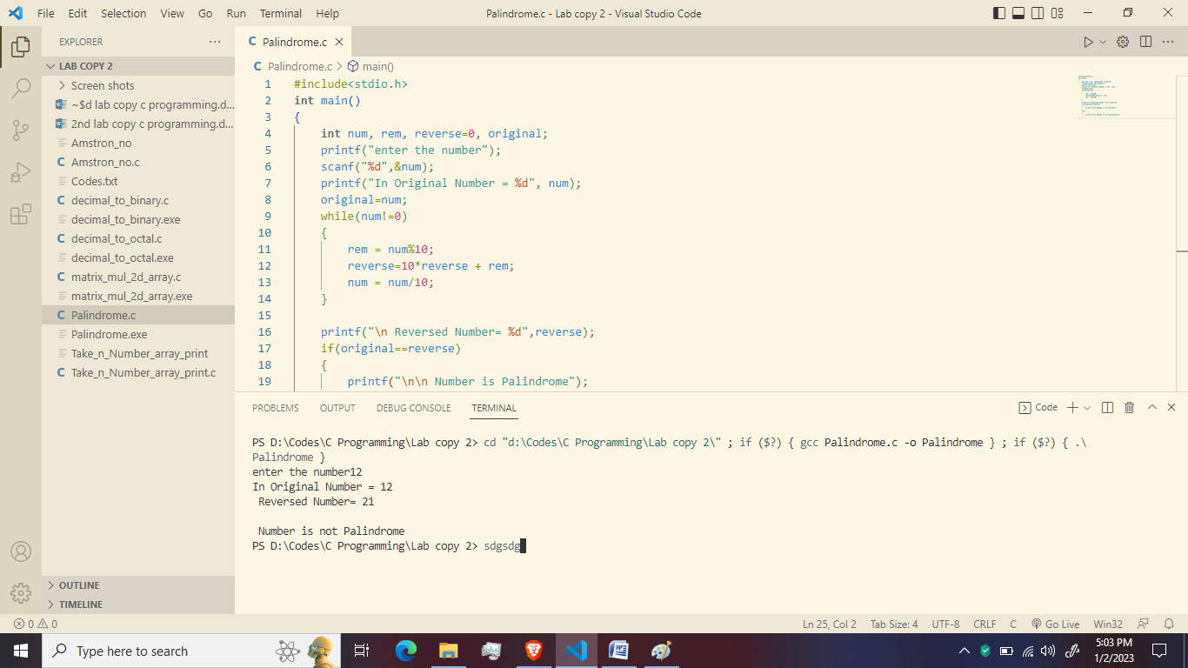

1. **Write a C program to find a number weather perfect number or not:-**

**Code:-**

#include<stdio.h>

void main()

{

int num, rem, sum = 0,i;

printf("Enter a number\n");

scanf("%d", &num);

for(i=1; i < num; i++)

{

rem = num%i;

if (rem==0)

{

sum = sum+i;

}

}

if (sum == num)

printf("%d is a Perfect Number");

else

printf("\n %d is not a Perfect Number");

}

**Output:-**

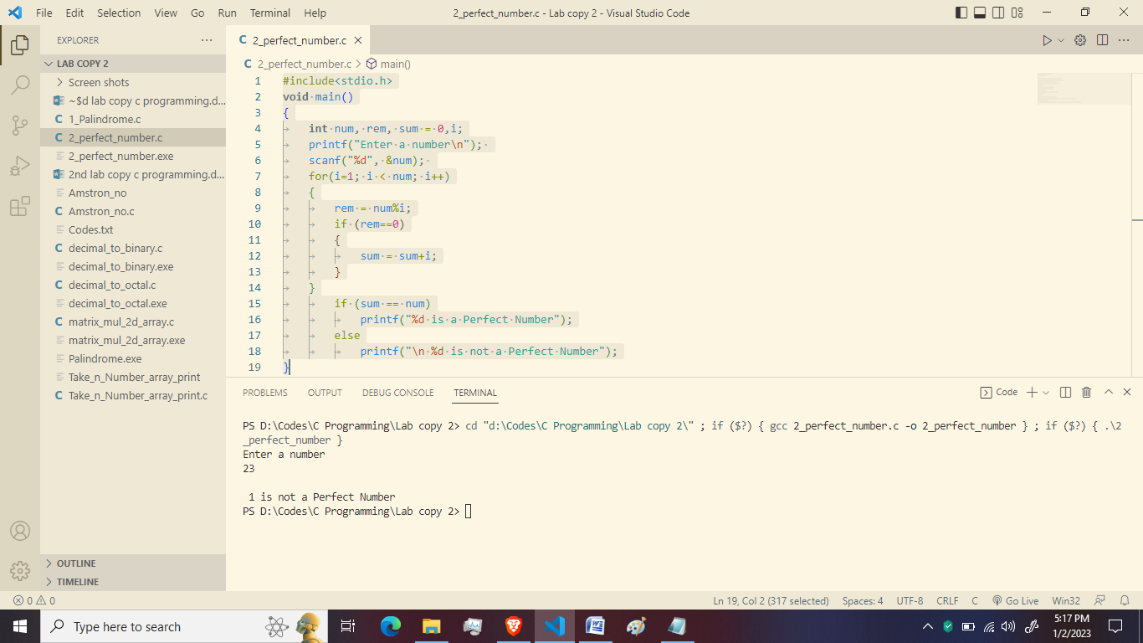

1. **Write a program to calculate the factorial of number using recursion:-**

**Code**:-

#include<stdio.h>

**long** **int** multiplynumbers(**int** n);

**int** main()

{

**int** n;

    printf("enter a positive integer:");

    scanf("%d",&n);

    printf("factorial of %d=%d",n,multiplynumbers(n));

    return 0;

}

**long** **int** multiplynumbers(**int** n)

{

    if(n>=1)

        return n*multiplynumbers(n-1);

    else

        return 1;

}

**Output:-**

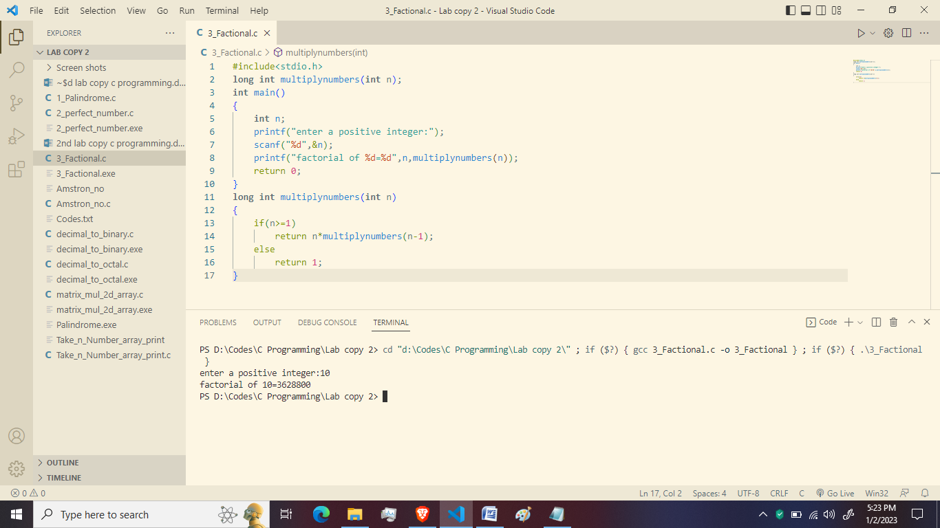

1. **Write a C program to the sum of all the digits of a number:-**

**Code:-**

#include<stdio.h>

int main(void)

{

int number,sum=0,rem;

printf("\n Enter the number:");

scanf("%d",&number);

while(number>0)

{

rem=number%10;

sum=sum+rem;

number=number/10;

}

printf("\n Desired the sum=%d",sum);

}

**Output:-**

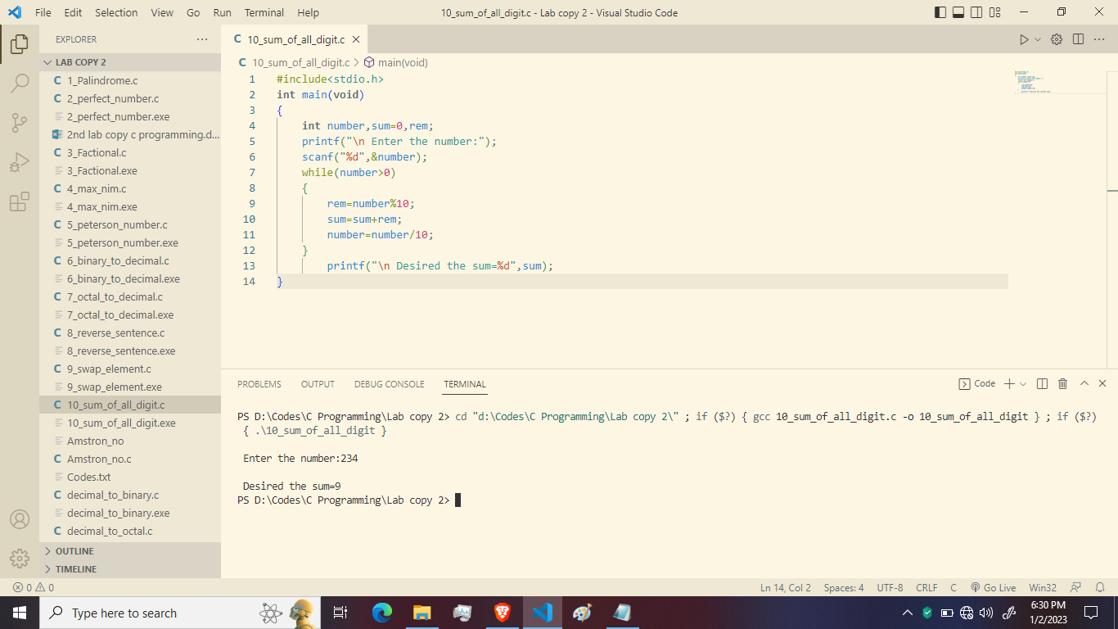

1. **Write a C program to convert number of days to Year, Month and Days:-**

**Code:-**

#include<stdio.h>

int main(void)

{

int num,year,mon,day;

printf("\n Enter the number of day:");

scanf("%d",&num);

year=num/365;

mon=(num-year*365)/30;

day=(num-year*365-mon*30);

printf("\n Years=%d",year);

printf("\n Month=%d",mon);

printf("\n Day=%d",day);

}

**Output:-**

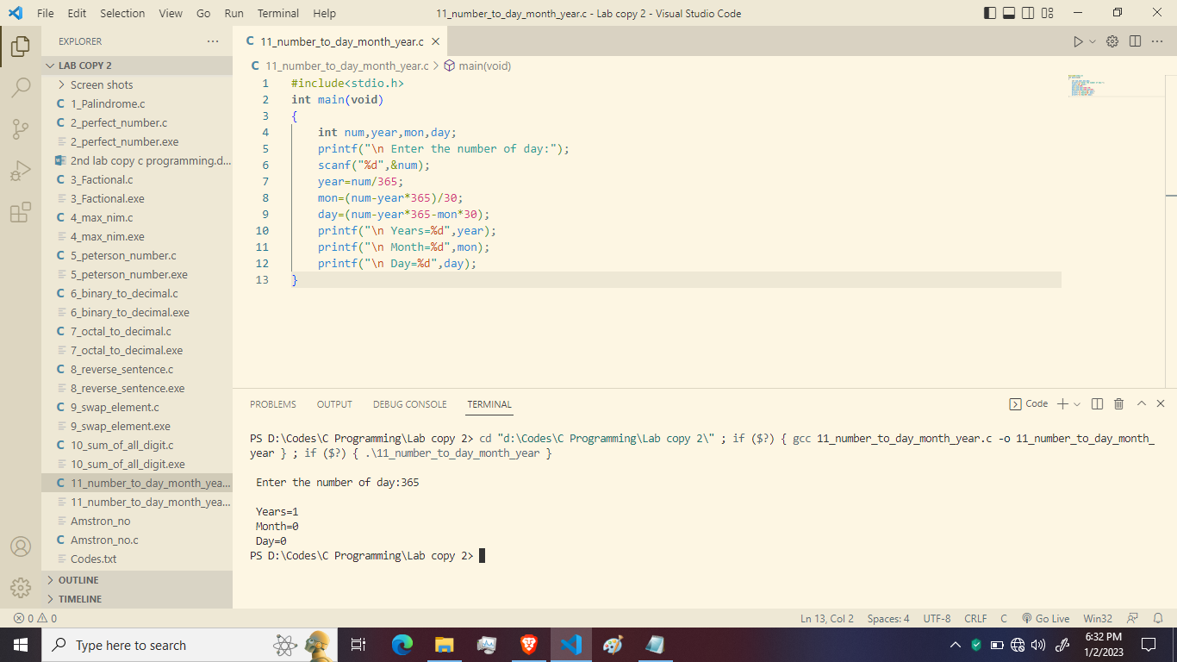

1. **Write a C program to calculate HCF & LCM:-**

**Code:-**

#include<stdio.h>

int main(void)

{

int x,y,rem,prod;

printf("\n Enter the value:");

scanf("%d %d",&x,&y);

if(x<y)

{

x=x+y;

y=x-y;

x=x-y;

}

prod=x*y;

rem=x%y;

while(rem!=0)

{

x=y;

y=rem;

rem=x%y;

}

printf("\n Desired HCF=%d",y);

printf("\n Desired LCM=%d",prod/y);

}

**Output:-**

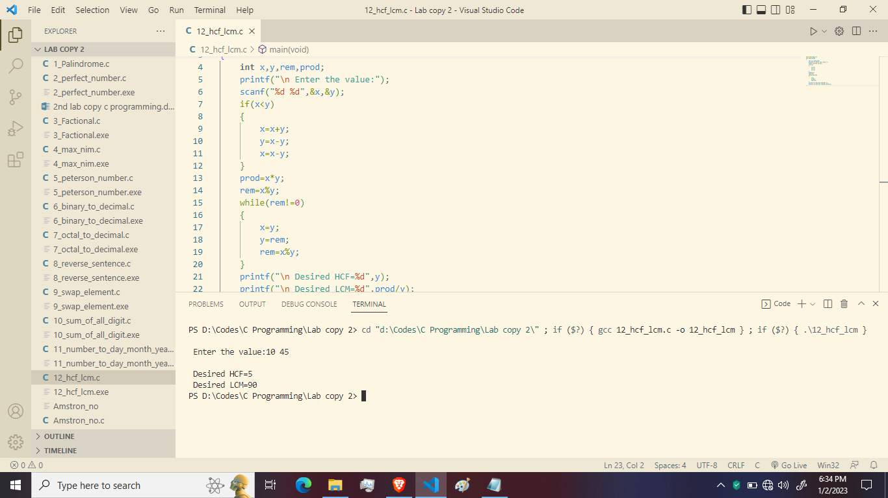

1. **Write a C program to find the sum of the following series:2+4+6+8+………..n terms:-**

**Code:-**

#include<stdio.h>

int main(void)

{

int n,i=2,sum=0;

printf("\n Enter the value:");

scanf("%d",&n);

while(i<=n)

{

sum=sum+i;

i=i+2;

}

printf("\n the sum=%d",sum);

}

**Output:-**

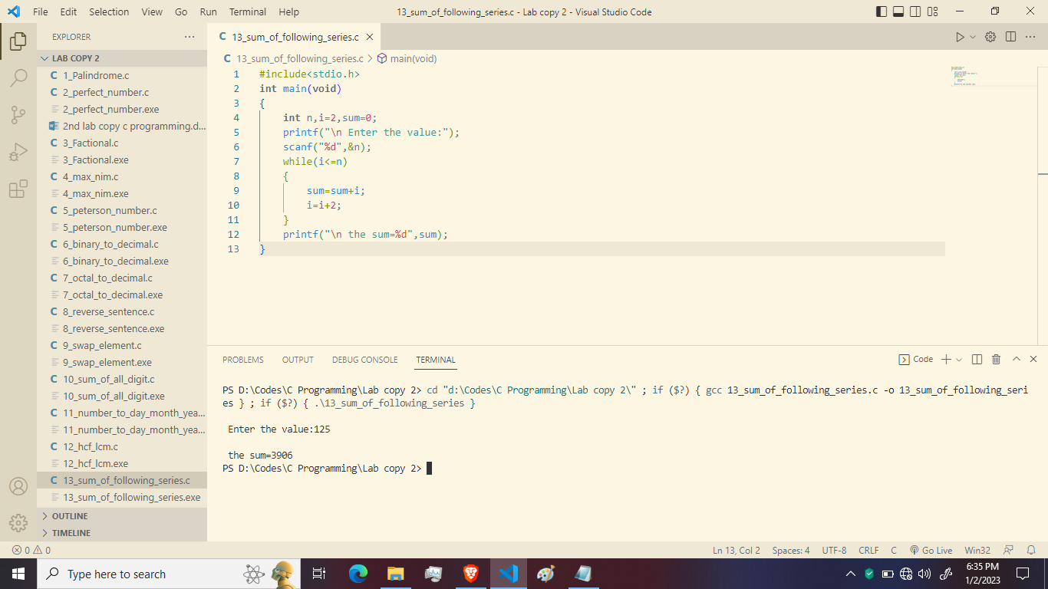

1. **Write a C program to add odd numbers in a given range:-**

**Code:-**

#include<stdio.h>

int main()

{

int a,b,i;

long int sum=0;

printf("Enter the range:");

scanf("%d %d",&a,&b);

printf("\n The Odd numbers that comes in the range between %d to %d\n",a,b);

for(i=a;i<=b;i++)

if(i%2==1)

{

sum=sum+i;

printf("%d",i);

}

printf("\n\n The sum of the odd numbers between the range is %d",sum);

}

**Output:-**

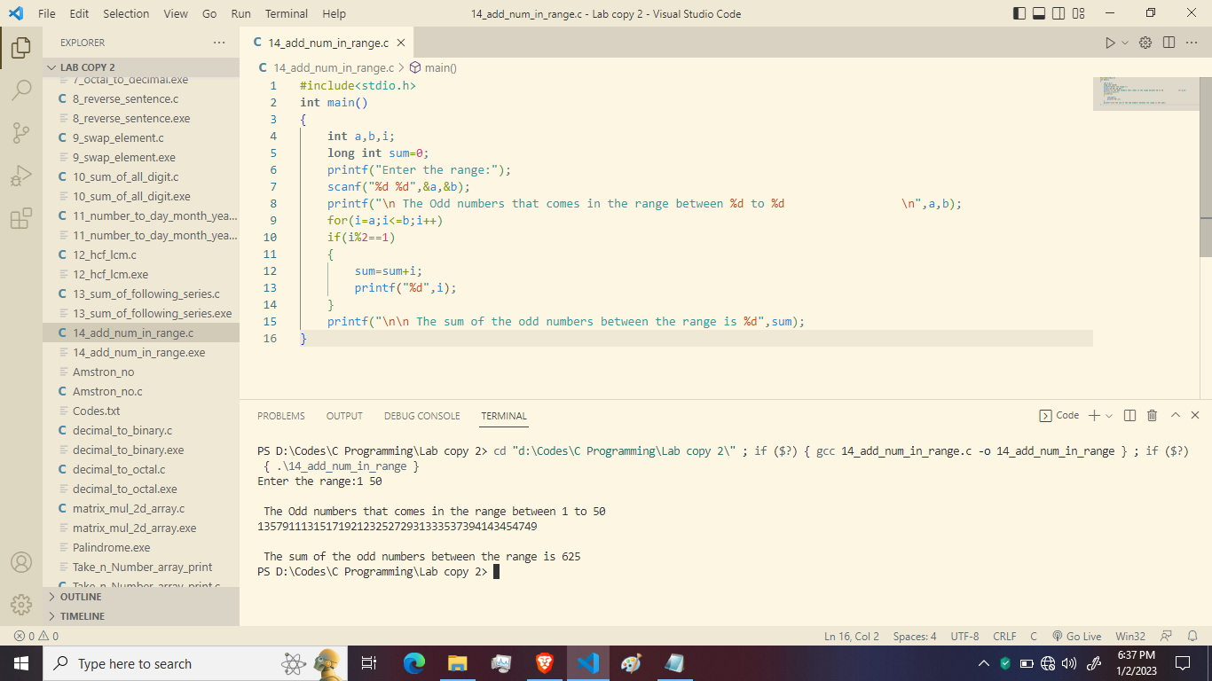

1. **Write a c programme to perform Peterson number or not:-**

**Code:-**

#include<stdio.h>

int main()

{

int num,temp,rem,sum=0,fact=1;

int i;

printf("Enter a number :");

scanf("%d",&num);

temp=num;

while(temp!=0)

{

rem=temp%10;

for(i=1;i<=rem;i++)

fact*=i;

sum+=fact;

fact=1;

temp/=10;

}

if(num==sum)

printf("%d is a Peterson Number",num);

else

printf("%d is not a Peterson Number",num);

return 0;

}

**Output:-**

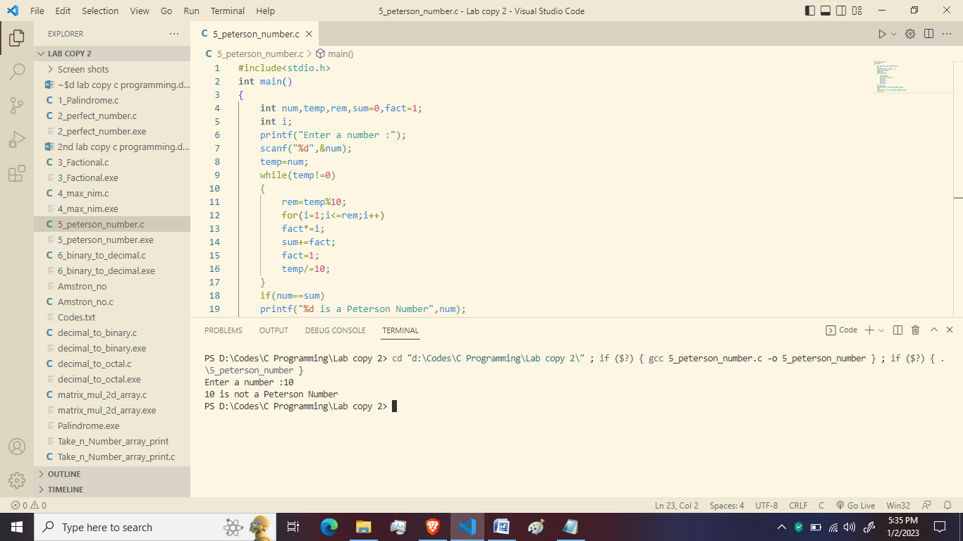

1. **Write a program to calculate binary to decimal:-**

**Code:-**

#include<stdio.h>

#include<math.h>

int convert(long long);

int main()

{

long long n;

printf("Enter a binary number :");

scanf("%d",&n);

printf("%d in binary=%d in decimal",n,convert(n));

return 0;

}

int convert(long long n)

{

int dec=0,i=0,rem;

while(n!=0)

{

rem=n%10;

n/=10;

dec+=rem*pow(2,i);

++i;

}

}

**Output:-**

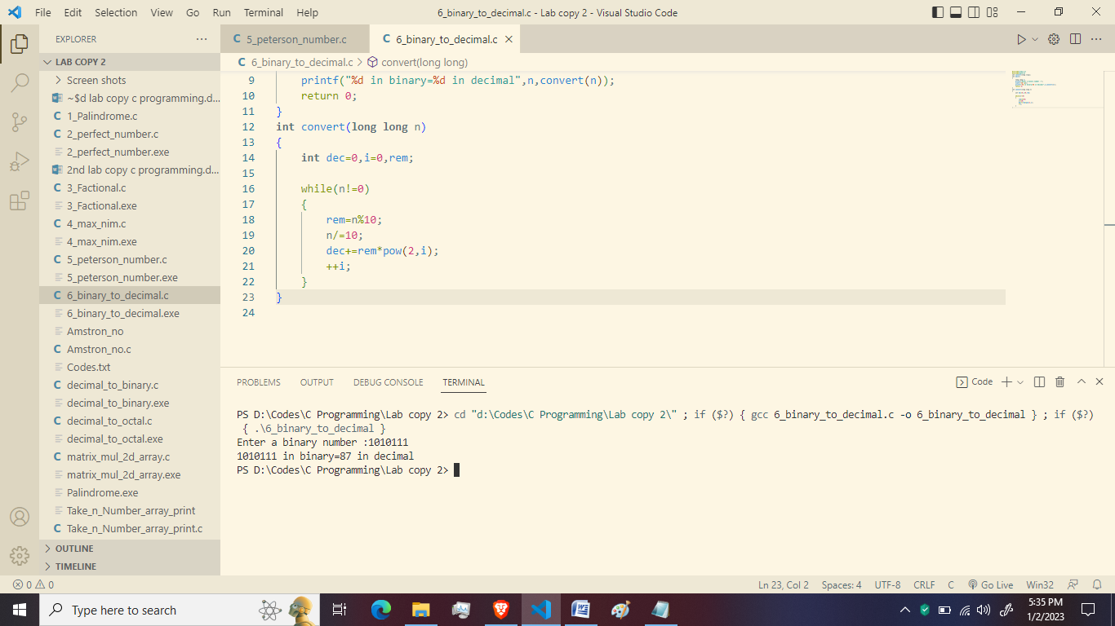

1. **Write a program to convert octal to decimal:-**

**Code:-**

#include<stdio.h>

#include<math.h>

long long convertOctalToDecimal(int octalNumber);

int main()

{

int octalNumber;

printf("Enter an octal number :");

scanf("%d",&octalNumber);

printf("%d in octal=%lld in decimal",octalNumber,convertOctalToDecimal(octalNumber));

return 0;

}

long long convertOctalToDecimal(int octalNumber)

{

int decimalNumber=0,i=0;

while(octalNumber!=0)

{

decimalNumber+=(octalNumber%10)*pow(8,i);

++i;

octalNumber/=10;

}

i=1;

return decimalNumber;

}

**Output:-**

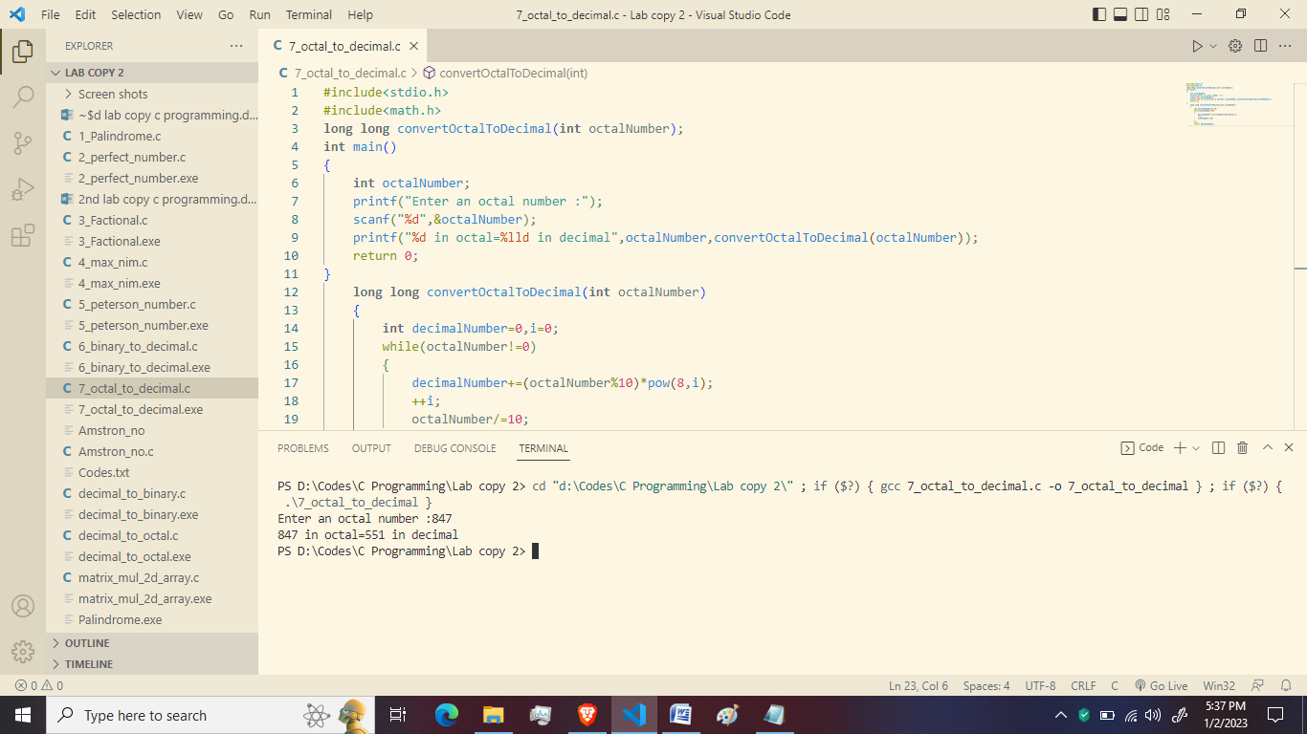

1. **Write a c program to reverse a sentence using recursion:-**

**Code:-**

#include<stdio.h>

void reverseSentence();

int main()

{

printf("Enter a sentence");

reverseSentence();

return 0;

}

void reverseSentence()

{

char c;

scanf("%c",&c);

if(c!='\n')

{

reverseSentence();

printf("%c",c);

}

}

**Output:-**

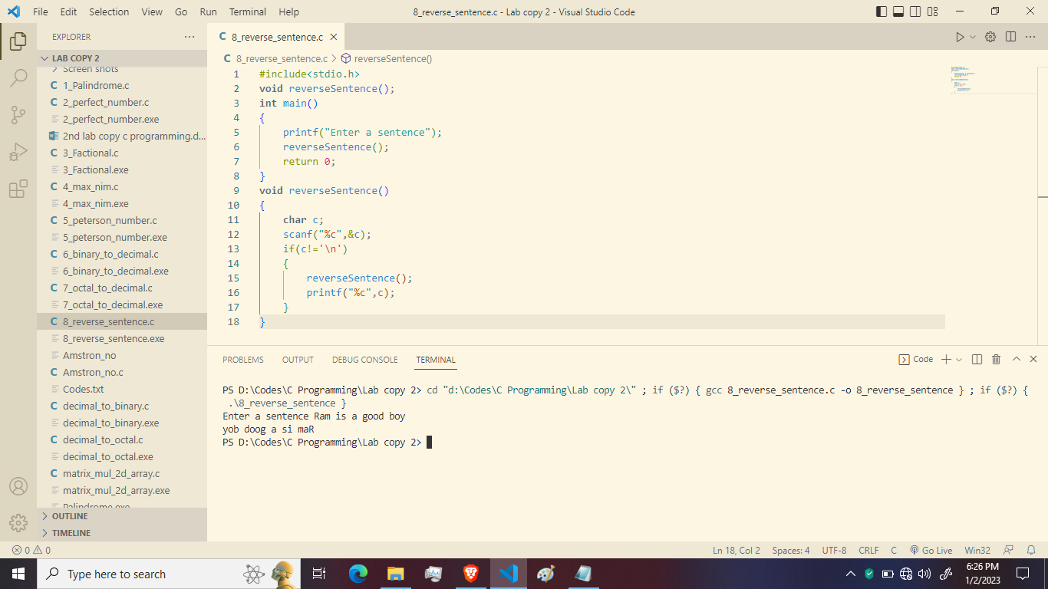

1. **Write a c program to swap elements using call by reference:-**

**Code:-**

#include<stdio.h>

void cyclicswap(int *a,int *b,int *c);

int main()

{

int a,b,c;

printf("Enter a, b & c respectivly : ");

scanf("%d%d%d",&a,&b,&c);

printf("value before swapping : \n");

printf("a=%d\nb=%d\nc=%d\n",a,b,c);

cyclicswap(&a,&b,&c);

printf("value after swapping :\n");

printf("a=%d\nb=%d\nc=%d",a,b,c);

return 0;

}

void cyclicswap(int *n1,int *n2,int *n3)

{

int temp;

temp=*n2;

*n2=*n1;

*n1=*n3;

*n3=temp;

}

**Output:-**

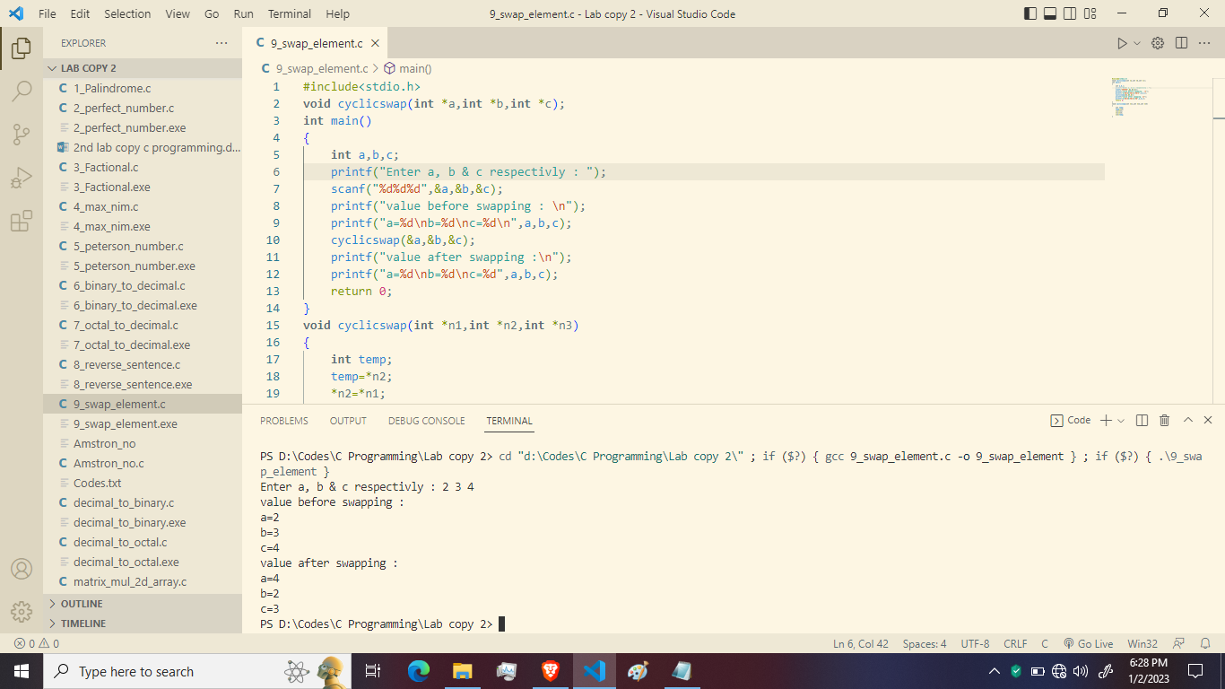

1. **Write a C program to find the number is Armstrong number or not:-**

**Code:-**

#include<stdio.h>

int main()

{

int number, sum=0, lastDigit, temp;

printf("Enter a number: ");

scanf("%d", &number);

temp = number;

while (temp!=0)

{

lastDigit = temp%10;

sum = sum + (lastDigit * lastDigit * lastDigit);

temp = temp/10;

}

if (sum == number)

{

printf("\n The Amstrong number is = %d", number);

}

else

printf("\n %d is not an Amstrong number\n", number);

return 0;

}

**Output:-**



1. **Write a C program to take n numbers from user and store then in an array and print the elements:-**

**Code:-**

#include<stdio.h>

int main()

{

int a[5], i;

printf("Enter five numbers: ");

for ( i = 0; i < 5; i++)

{

scanf("%d", &a[i]);

}

printf("\n The array contains: \n");

for ( i = 0; i < 5; i++)

{

printf("%d", a[i]);

}

return 0;

}

**Output:-**

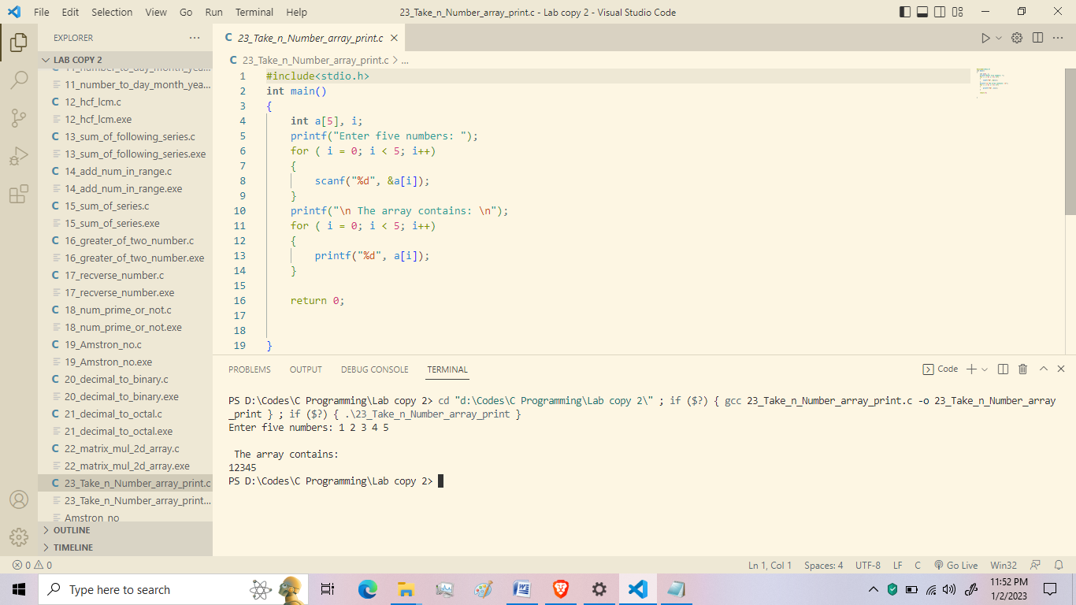

1. **Write a C program to perform matrix multiplication operation using 2d array:-**

**Code:-**

#include<stdio.h>

int main()

{

int a[10][10], b[10][10], c[10][10], n, i, j, k;

printf("Enter the value of N (N<=10): ");

scanf("%d", &n);

printf("\n Enter the element of Matrix-A: ");

for ( i = 0; i < n; i++)

{

for ( j = 0; j < n; j++)

{

scanf("%d", & a[i][j]);

}

}

printf("\n Enter the elements of Matrix-B: ");

for ( i = 0; i < n; i++)

{

for ( j = 0; j < n; j++)

{

scanf("%d", & b[i][j]);

}

}

for ( i = 0; i < n; i++)

{

for ( j = 0; j < n; j++)

{

c[i][j] = 0;

for ( k = 0; k < n; k++)

{

c[i][j]+=a[i][k]*b[k][i];

}

}

}

printf("\n The product of two Matrices is: ");

for ( i = 0; i < n; i++)

{

for ( j = 0; j < n; j++)

{

printf("%d\t", c[i][j]);

}

printf("\n");

}

}

**Output:-**

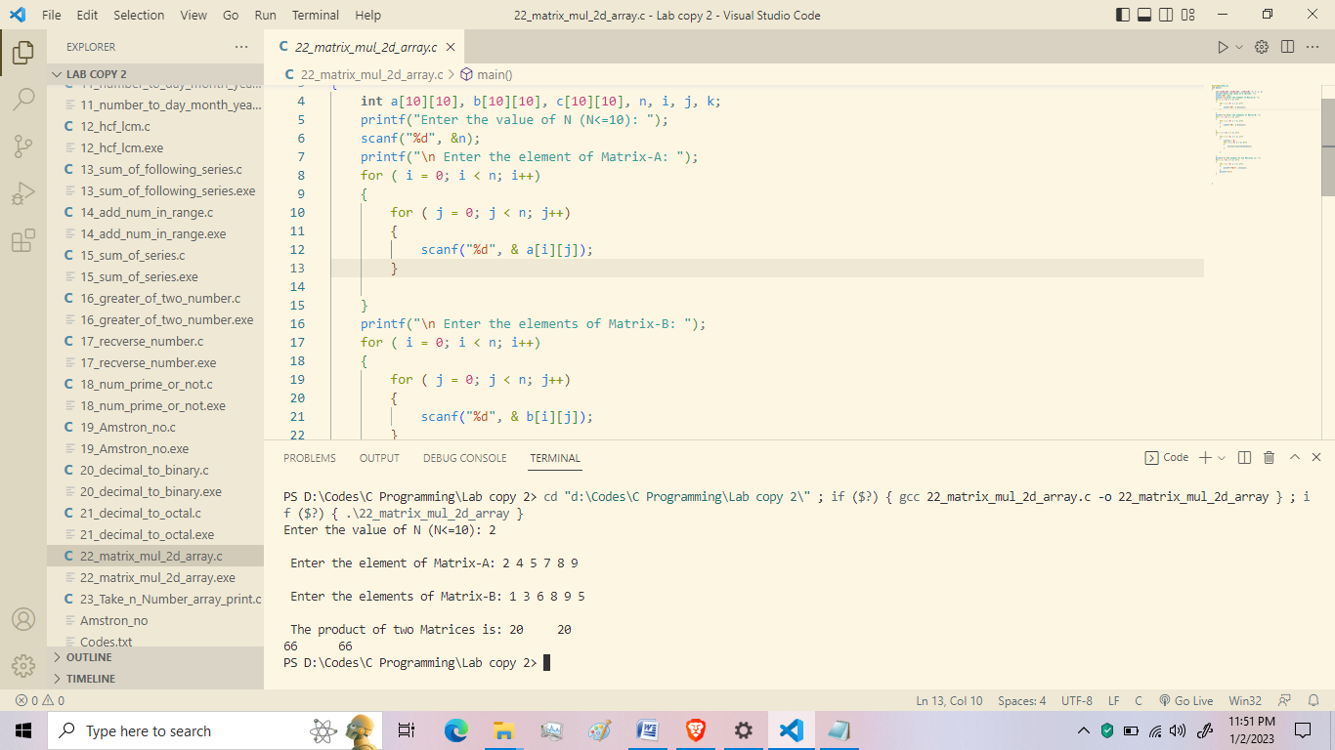

1. **Write a program to convert Decimal to Octal:-**

**Code:-**

#include<stdio.h>

#include<math.h>

int convertDecimalToOctal(int decimalNumber);

int main()

{

int decimalNumber;

printf("Enter the Decimal Number: ");

scanf("%d", &decimalNumber);

printf("%d in decimal = %d in octal", decimalNumber,convertDecimalToOctal(decimalNumber));

return 0;

}

int convertDecimalToOctal(int decimalNumber)

{

int octalNumber = 0, i=1;

while (decimalNumber !=0)

{

octalNumber +=(decimalNumber%8)*i;

decimalNumber /=8;

i*=10;

}

return octalNumber;

}

**Output:-**

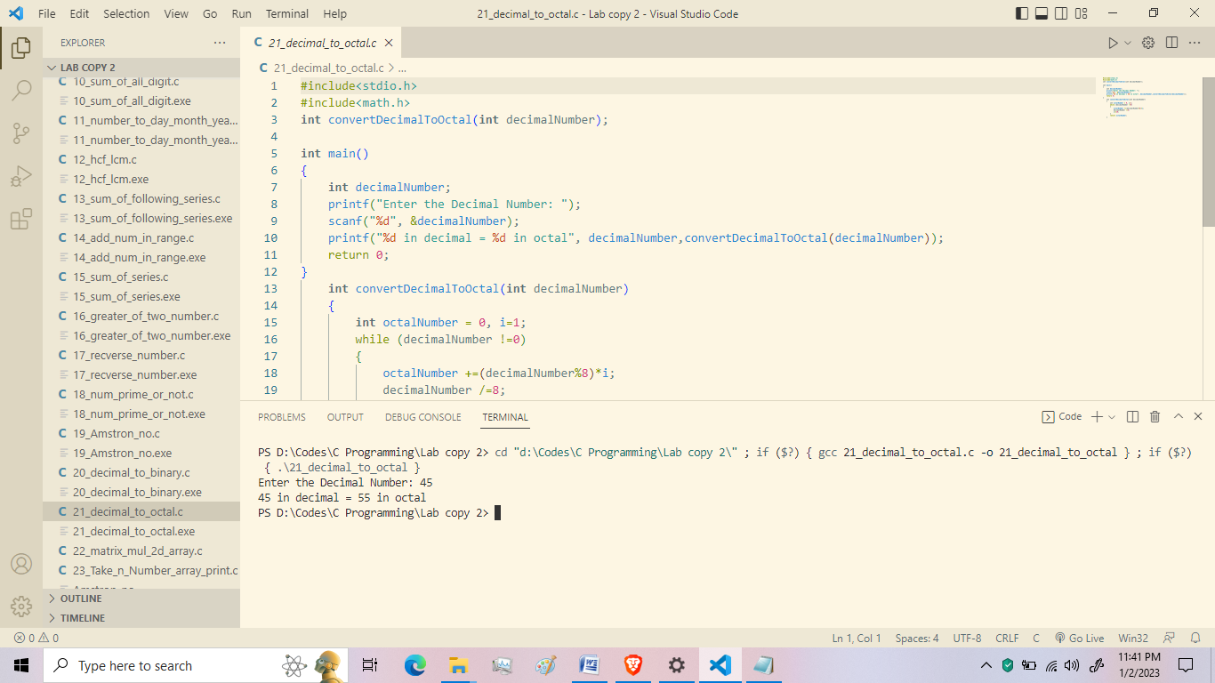

1. **Write a program to convert Decimal to Binary:-**

**Code:-**

#include<stdio.h>

#include<math.h>

long long convert(int);

int main()

{

int n, bin;

printf("Enter the decinmal number: ");

scanf("%d",&n);

bin = convert(n);

printf("%d in decimal = %d in binary", n, bin);

return 0;

}

long long convert(int n)

{

long long bin = 0;

int rem, i=1;

while (n!=0)

{

rem = n%2;

n/=2;

bin+= rem * i;

i*=10;

}

return bin;

}

**Output:-**

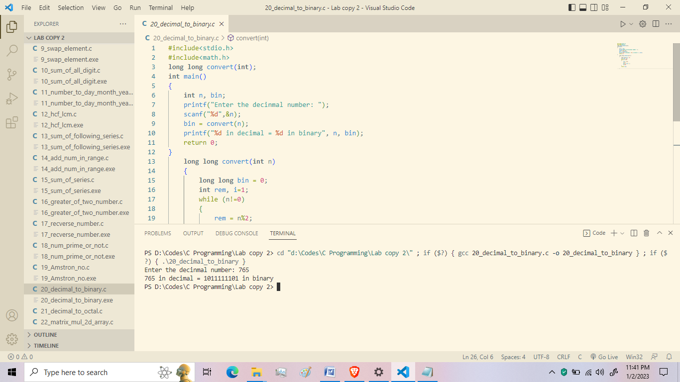

1. **Write a program in C to find out the sum of following series 12+32+52+72+…………..n terms:-**

**Code**:-

#include<stdio.h>

#include<math.h>

int main(void){

int n, i=1, sum=0;

printf("\n enter a value:");

scanf("%d" , &n);

while(i<=n){

sum=sum+pow(i,2);

i=i+2;

}

printf("\n The sum =%d" , sum);

}

**Output:-**

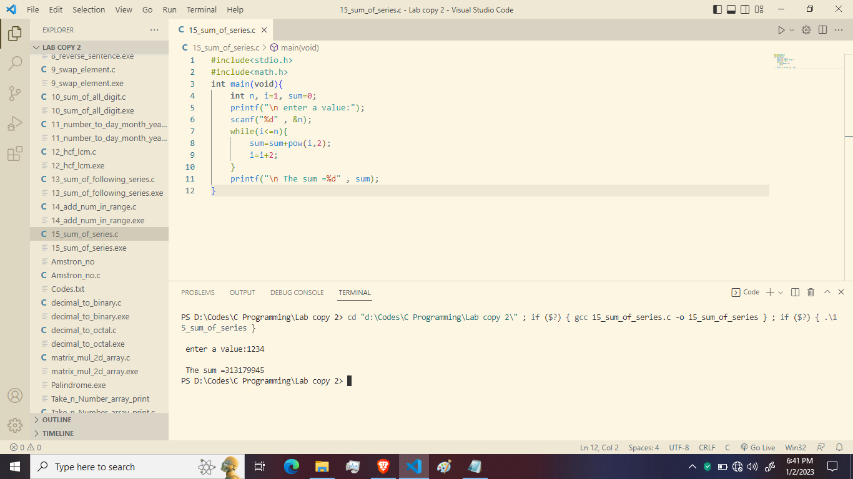

1. **Write a program in C to calculate the greater of two numbers using ternary operator:-**

**Code:-**

#include<stdio.h>

#include<math.h>

int main(){

int a,b;

printf("\n Enter the numbers:-");

scanf("%d %d" , &a ,&b);

(a>b)? printf("\n %d is the greater" , a) : printf("\n %d is greater" , b);

}

**Output:-**

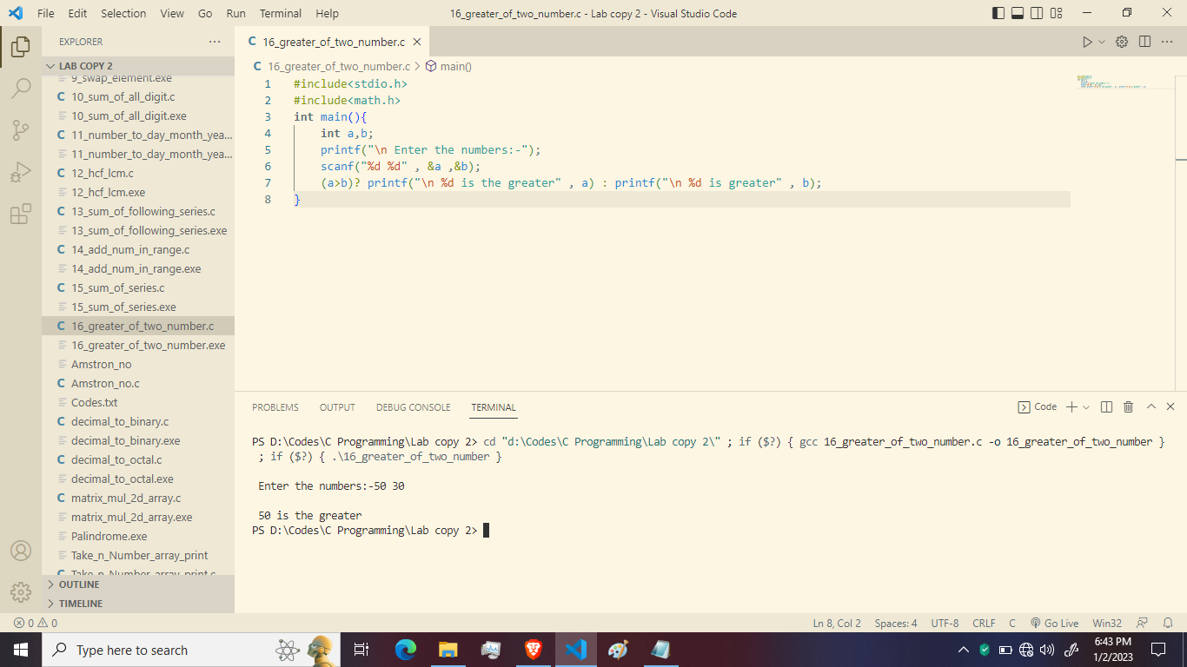

1. **Write a C program to reverse a number:-**

**Code:-**

#include<stdio.h>

int main(){

int num ,rem, reverse=0;

printf("Enter a number:-");

scanf("%d" , &num);

printf("\n Original number=%d" , num);

while(num!=0){

rem=num%10;

reverse=reverse*10+rem;

num=num/10;

}

printf("\n The reversed number is %d" , reverse);

}

**Output:-**

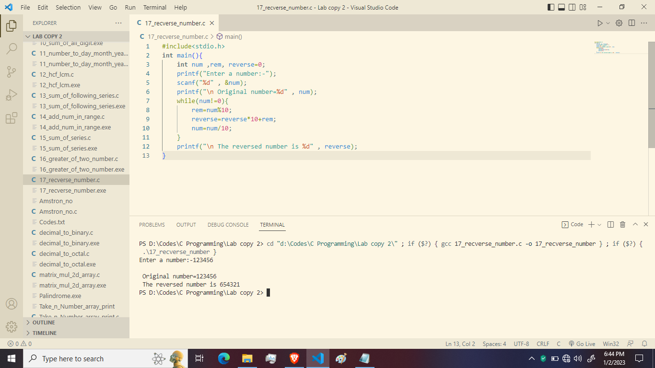

1. **Write a C program to find weather the number is prime or not using function.**

**Code:-**

#include<stdio.h>

int check_prime(int);

main(){

int n,result;

printf("Enter an integer to check wheather it is prime number or not.\n");

scanf("%d" , &n);

result=check_prime(n);

if(result==1)

printf("%d is a prime.\n",n);

else

printf("%d is not a prime.\n",n);

return 0;

}

int check_prime(int a){

int c;

for(c=2; c<=a-1; c++){

if(a%c==0)

return 0;

}

return 1;

}

**Output:-**

